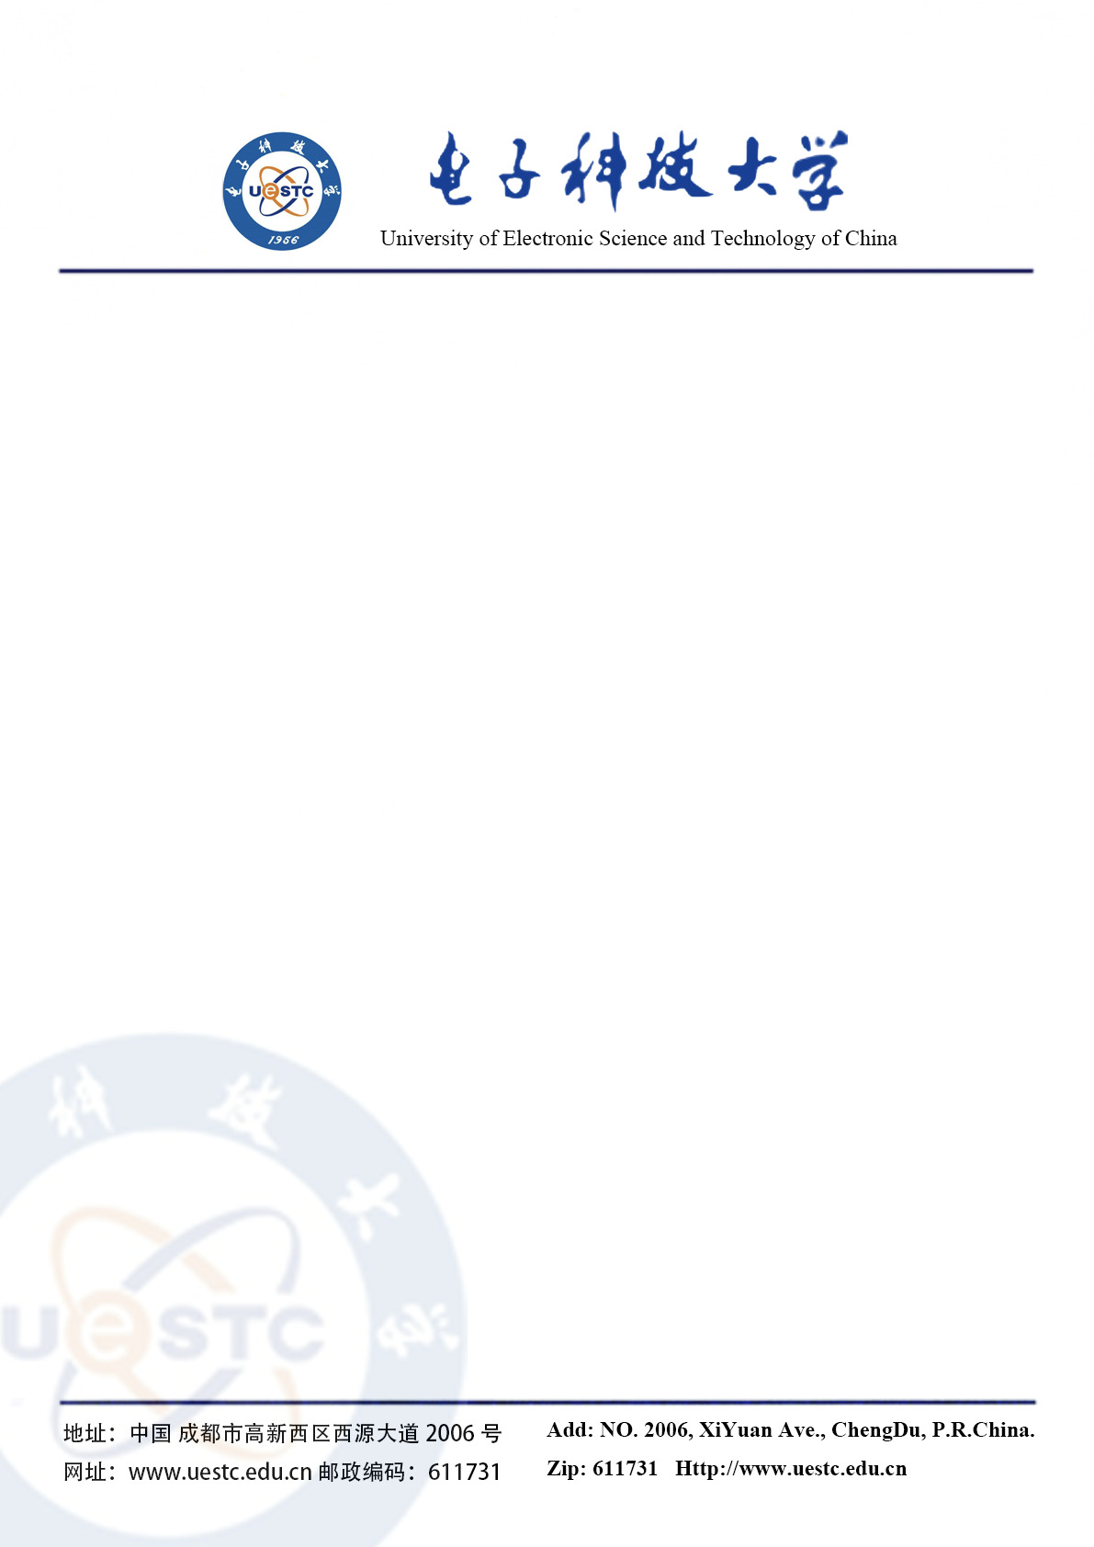

To the Admission Department at King College London:

I am delighted to write this reference letter for Mr Ruichang Zhang. I am the associate researcher in IntelliGame Lab and also acts as his second supervisor. He proved himself to be very diligent, creative and resourceful and completed his project to a very high standard.

In August 2020, I was deputy project manager of the project of Screening Suspected Patient through Supervised Learning, which is Key Emergency R&D Project of Sichuan Science and Technology Department. Ruichang was mainly responsible for feather engineering and model selection. According to our estimation, his work improves the accuracy of the work from 68% to 86%. He finished his part with high efficiency and impressive quality.

It is one of the pleasures of academic life to see students develop and find their path during their MSc. When he first arrived at UESTC there already was promise. But it was during the KDD Cup 2021 and NeurIPS L2RPN competition 2020, where I was impressed by his exceptional level of motivation do learn and improve his research. I also had the pleasure to be his internal examiner for the opening and interim stages of his projects.

Over the course of these examinations, I saw considerable growth with each new challenge I confronted him with. Instead of being intimidated by difficult questions, he quickly learned ways to analyse and then find methods to best answer them. This could also be seen in his projects, where he developed new methods to test a hypothesis, after he correctly assessed that the already existing database was not able to give him the data he needs. This method, which can be found his proposal and which I consider his most important contribution, allowed fascinating insights into the application of deep reinforcement learning into electric vehicle charging market.

During his years at the research group I also learned to know him as respectful, honest and polite young man. Since the complex issues we face in engineering can only be solved by teams of experts working together, this is of great importance and makes him a valuable member to any research team he works with. It also made him easy to talk to in social events that were organised by the IntelliGame Lab. I consider his ability of speaking English as excellent, both in scientific terms and at social events. Overall I would like to highly recommend Ruichang Zhang for chasing his PhD career. Please do not hesitate to contact me if you have further questions



Sincerely,



Yan Wang, associate researcher

Department of Computer Science and Technology, UESTC

IntelliGame Lab

Mobile: +86 173 0826 9997

Email: yanbo1990@uestc.edu.cn